**Right There Questions**

* Who­­­­­­­­­_____?
* What_____?
* Where_____?
* When______?

**Think and Search**

* Why_____?
* What cause_____?
* Tell me in your own words_____?
* What happened first, second or third?
* What are the characteristics of_____?
* Characters/setting/Problem/Events/

Solutions?

**Author and You**

* What can you infer about ____’s feelings in this section of the text?
* 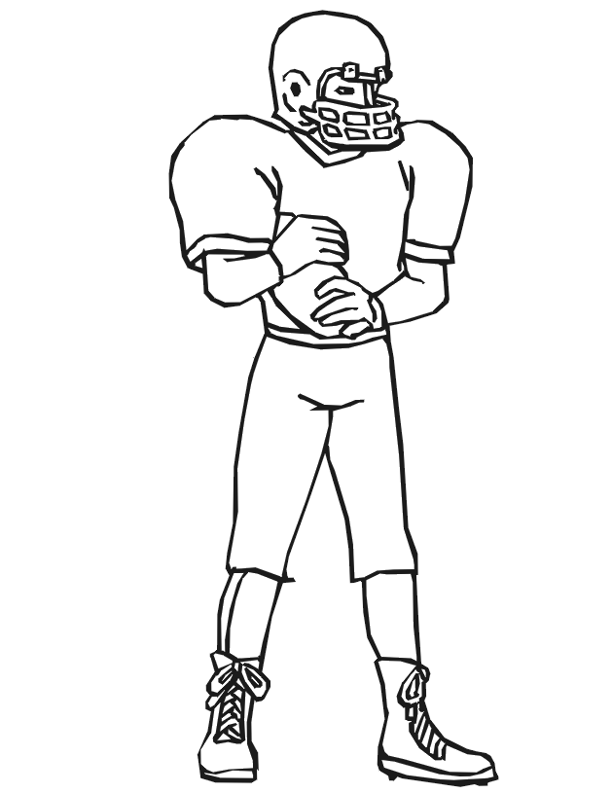What do you predict will happen next?

Why do you think so?

* The setting is never stated but where do you think the story takes place?
* Why____?
* What if____?
* What does the author mean when____?
* Tell me the most important

reason____?

* What are the themes of this text?
* Tell me the biggest problem____?

**On My Own**

* Do you think______?
* How would you_____?
* Which is better_____?
* Would you agree that____?
* Were you ever____?
* In your opinion____?
* Would it be better if____?

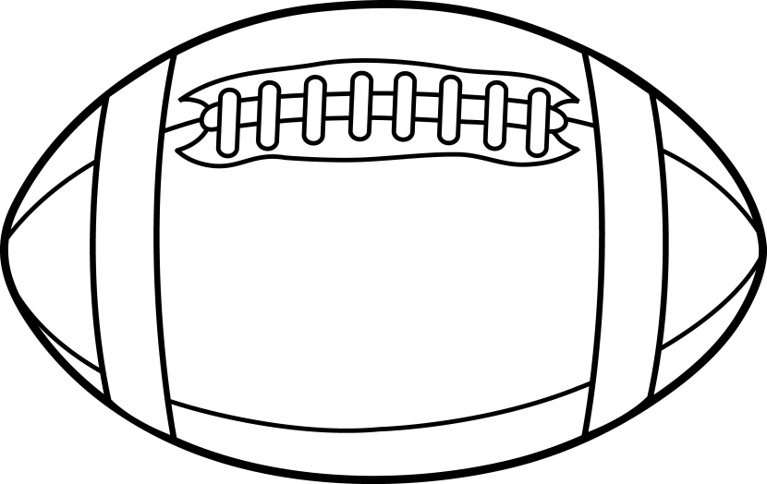

Student

QAR

Bookmark